PHP Webservice的发布与调用

- 环境配置
配置php.ini，把php_soap.dll前面的分号去掉
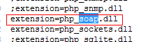

重启apache后通过phpinfo()查看
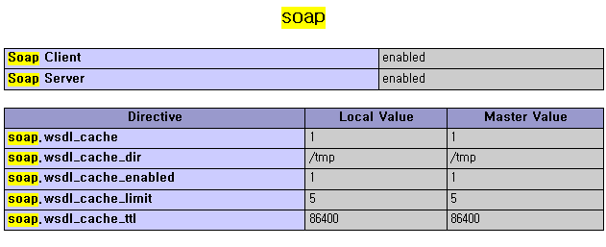
这样是表示环境已经支持soap的webservice了，后面的事情就是写代码了。

- webservice的发布
发布出来的*.wsdl文件，其实是一个xml格式的文件，生成这个文件可以通过第3方软件，如ZendStudio 5.5.1就可以生成。
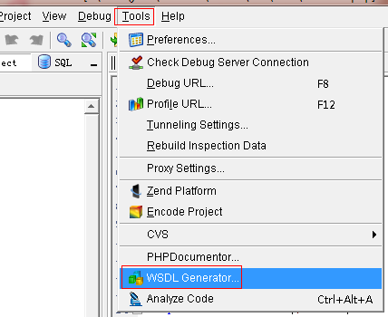
示例，我用以下代码生成：
<?php
class CTest
{
public function __construct()
{

}

/**
*
* @param string $oParams
* @return string
*/
public function Add($oParams)
{
$sParams = $oParams->oParams;
$oParams = json_decode($sParams);
$a = $oParams->a;
$b = $oParams->b;
$c = $a+$b;
return array('AddResult'=>$c);
}
}
?>
生成的xml文件是：
<?xml version="1.0" encoding="UTF-8" ?>
- <wsdl:definitions targetNamespace="http://tempuri.org/" xmlns:tm="http://microsoft.com/wsdl/mime/textMatching/" xmlns:soapenc="http://schemas.xmlsoap.org/soap/encoding/" xmlns:mime="http://schemas.xmlsoap.org/wsdl/mime/" xmlns:tns="http://tempuri.org/" xmlns:s="http://www.w3.org/2001/XMLSchema" xmlns:soap="http://schemas.xmlsoap.org/wsdl/soap/" xmlns:soap12="http://schemas.xmlsoap.org/wsdl/soap12/" xmlns:http="http://schemas.xmlsoap.org/wsdl/http/" xmlns:wsdl="http://schemas.xmlsoap.org/wsdl/">
- <wsdl:types>
- <s:schema elementFormDefault="qualified" targetNamespace="http://tempuri.org/">
- <s:element name="AddRequest">
- <s:complexType>
- <s:sequence>
<s:element minOccurs="0" maxOccurs="1" name="oParams" type="s:string" />
</s:sequence>
</s:complexType>
</s:element>
- <s:element name="AddResponse">
- <s:complexType>
- <s:sequence>
<s:element minOccurs="0" maxOccurs="1" name="AddResult" type="s:string" />
</s:sequence>
</s:complexType>
</s:element>
</s:schema>
</wsdl:types>
- <wsdl:message name="AddSoapIn">
<wsdl:part name="parameters" element="tns:AddRequest" />
</wsdl:message>
- <wsdl:message name="AddSoapOut">
<wsdl:part name="parameters" element="tns:AddResponse" />
</wsdl:message>
- <wsdl:portType name="CTestSoap">
- <wsdl:operation name="Add">
<wsdl:input message="tns:AddSoapIn" />
<wsdl:output message="tns:AddSoapOut" />
</wsdl:operation>
</wsdl:portType>
- <wsdl:binding name="CTestSoap" type="tns:CTestSoap">
<soap:binding transport="http://schemas.xmlsoap.org/soap/http" />
- <wsdl:operation name="Add">
<soap:operation soapAction="http://tempuri.org/Add" style="document" />
- <wsdl:input>
<soap:body use="literal" />
</wsdl:input>
- <wsdl:output>
<soap:body use="literal" />
</wsdl:output>
</wsdl:operation>
</wsdl:binding>
- <wsdl:binding name="CTestSoap12" type="tns:CTestSoap">
<soap12:binding transport="http://schemas.xmlsoap.org/soap/http" />
- <wsdl:operation name="Add">
<soap12:operation soapAction="http://tempuri.org/Add" style="document" />
- <wsdl:input>
<soap12:body use="literal" />
</wsdl:input>
- <wsdl:output>
<soap12:body use="literal" />
</wsdl:output>
</wsdl:operation>
</wsdl:binding>
- <wsdl:service name="CTest">
- <wsdl:port name="CTestSoap" binding="tns:CTestSoap">
<soap:address location="http://192.168.6.44:80/webservice/server/server.php?wsdl" />
</wsdl:port>
- <wsdl:port name="CTestSoap12" binding="tns:CTestSoap12">
<soap12:address location="http://192.168.6.44:80/ webservice/server/server.php?wsdl" />
</wsdl:port>
</wsdl:service>
</wsdl:definitions>

生成xml文件后，就要通过一个服务发布出去，如：
<?php
error_reporting(E_ALL & ~E_DEPRECATED & ~E_NOTICE);
include_once('../class/test.class.php');
$server = new SoapServer('wscache/CTest.1.0.wsdl');
$server->setClass('CTest');
$server->handle();
?>
然后可以向其他人或者系统提供出发布的地址，如：
http://192.168.6.44/webservice/server/server.php?wsdl

- webservice的调用
通过上面提供的地址，写一个调用页面
<?php
error_reporting(E_ALL & ~E_DEPRECATED & ~E_NOTICE);
header("Content-Type: text/html;charset=utf-8");
$client = new SoapClient('http://192.168.6.44/webservice/server/server.php?wsdl');
$str = '{"a":1,"b":20}';
//调用方法一
$r = $client->Add(array('oParams'=>$str)); //数组
//调用方法二
//$pParams->oParams = $str;
//$r = $client->__call('Add',array($pParams));//这个得是对象
var_dump($r);
?>

